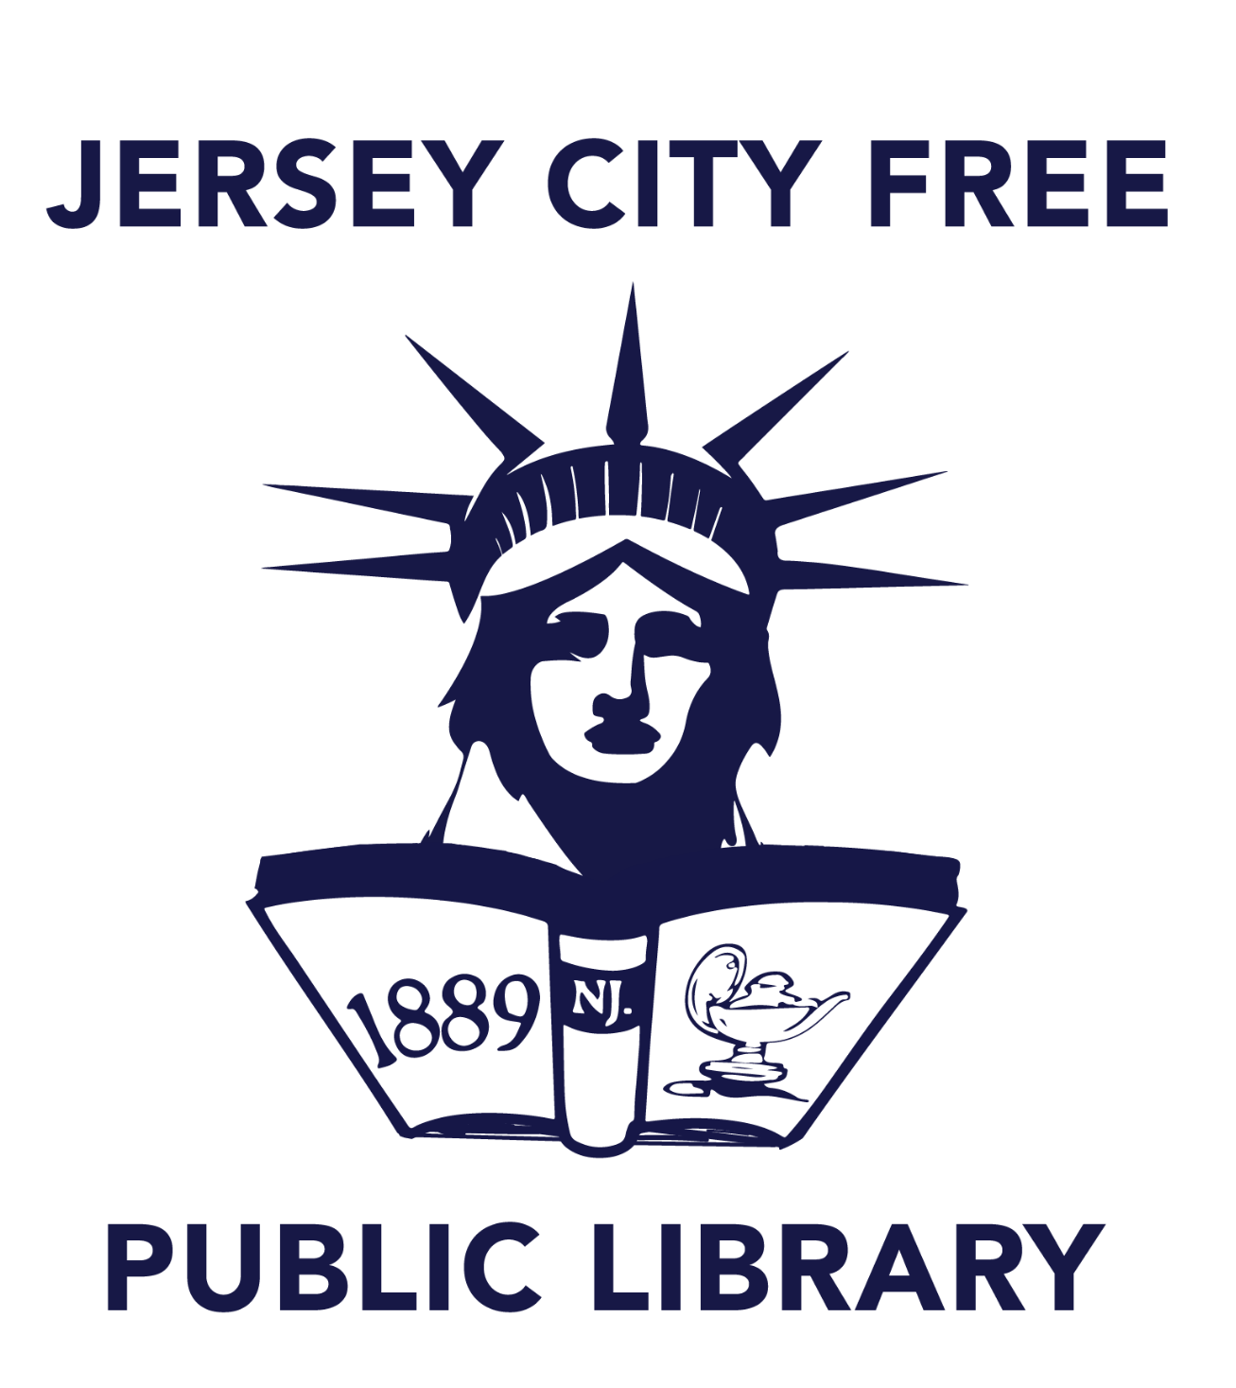

**FOR IMMEDIATE RELEASE**  
10/8/24

**Jersey City Free Public Library**  
Nailah Andre  
PR & Communications Coordinator  
[nandre@jclibrary.org](mailto:nandre@jclibrary.org)

**MILLER BRANCH AUDITORIUM TO BE DEDICATED IN HONOR OF COMMUNITY ACTIVIST DAOUD-DAVID WILLIAMS**

Jersey City, New Jersey — Tuesday, October 8, 2024 — Jersey City Free Public Library (JCFPL) is pleased to announce that the Miller Branch Library auditorium will be named after longtime community activist and educator Daoud-David Williams. We are naming the auditorium to the Daoud-David Williams Cultural Arts Center to honor Daoud’s profound impact as co-founder of Community Awareness Series (CAS). CAS is a JCFPL department that serves as an ambassador in the arts for the community by organizing and conducting live performances, workshops, educational forums, and institutional outreach in Jersey City, Hudson County, and beyond.

Terry B. Hill, Library Director for Jersey City Free Public Library shared, “It is a great honor to dedicate this auditorium to Daoud-David Williams, whose co-founding of the Community Awareness Series (CAS) has left an indelible mark on Jersey City Free Public Library and the people of Jersey City.”

Hill continues, “From facilitating music workshops to educating patrons on social issues, Daoud’s work through CAS has empowered our community, fostering unity, creativity, and cultural exchange. The Daoud-David Williams Cultural Arts Center will stand as a testament to his legacy, continuing to host performances, workshops, and events that enrich our patrons.”

CAS was founded in 1977 as a collaboration between the Miller Branch Library and the Spirit of Life Ensemble. From the start, CAS has been dedicated to providing high-quality cultural experiences and educational programs to Jersey City's underserved communities. Daoud's deep community ties have enabled him to bring numerous local musicians, poets, and activists to the library, offering our patrons insightful and enriching programs. Their Live Performance Series’ mainstay is jazz, but CAS hosts world beat, folk, blues, gospel, rock, and classical music. Another component of the live performance is dance and spoken word. The Workshop/Forum Series highlights social development, creative endeavors, information sharing, and resource distribution in an informal setting.

CAS embodies the finest qualities of the Jersey City Free Public Library and highlights the vital services libraries can offer their communities. Under Daoud’s leadership, CAS has fostered a unique relationship with Miller Branch patrons and the surrounding community. CAS programming has often highlighted the culture and history of oppressed peoples, celebrating events like Juneteenth and Kwanzaa long before institutions widely recognized holidays such as these. Even today, Daoud remains actively involved in the CAS community, advancing his vision of community education and cultural expression.

Sam Williams, son of Daoud-David Williams, reflected on his father’s legacy, “My earliest experiences of anything culture-related were here at Miller Branch. Every experience that I've had here, through my parents, has just been a blessing and honor. They provided guidance and really gave me a sense of history. All the folks that I've met over the years have shaped and crafted me. It gave me a sense of purpose, of standing for things that I believe to be right. They gave me the foundation of what to stand for as a human being.”

Councilman At-Large Daniel Rivera, who introduced the ordinance to name the library auditorium after Daoud-David Williams, remarked, “You can't get to a place that you don't believe exists. Daoud-David Williams embodies this. A cornerstone of the Miller Branch Library will forever be remembered and recognized.”

The Daoud-David Williams Cultural Arts Center will serve as a tribute to a cultural icon in Jersey City. The auditorium naming ceremony will occur on Saturday, October 12th, at the Miller Branch Library at 6:30 p.m.

**About Jersey City Free Public Library**

The Jersey City Free Public Library (JCFPL) is the largest municipal library in the State of New Jersey, serving one of the most diverse cities in the country. The Library meets the needs of the community by providing a wide array of programming and resources, and access to a broad range of print, digital, and audiovisual collections. The Library has been a cornerstone of Jersey City’s growing and changing community for more than 120 years.